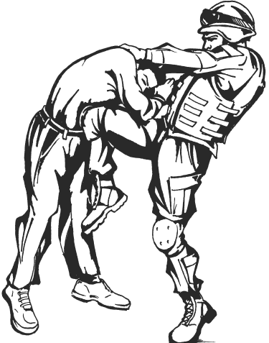

**CERTIFICATE OF TRAINING**

This is to certify that

**ANTHONY SMITH JR.**

has successfully completed the

TACTICAL COMBATIVES COURSE (80 hours)

**07 – 18 March 2011**

**Given this 18th Day of March 2011**

____________________ ____________________

**MARC W. HICKEY JODY C. MILLER**

**SFC, USA LTC, IN**

**PRIMARY INSTRUCTOR COMMANDING**